International Journal of Sensors and Communication Technologies
www.celtiquepublications.fr

THE TITLE OF THE ARTICLE GOES HERE,
First Author^{1*}, Second Author², Third Autor³

¹ Affiliation of first author
email: ORCID:

² Affiliation of second author
email: ORCID:

³ Affiliation of third author
email: ORCID:

Abstract: The abstract is a single, dense paragraph of 200-250 words. It is the most read part of your paper and must stand alone. Structure it to clearly answer these points in order. Context & Problem: Start with one or two sentences on the broader field and the specific challenge or gap your research addresses. Objective/Method: State the primary aim of your study. Briefly describe the core methodology or approach used (e.g., "This paper presents the design and field evaluation of a novel..."). Key Results/Findings: Summarize the most critical quantitative or qualitative outcomes. Use numbers and data where possible (e.g., "Experimental results show a 40% improvement in efficiency..."). Conclusion/Significance: Conclude with the main takeaway and its implication for the field or practice. Do not include citations, undefined acronyms, or references to figures/tables. Write in the past tense for completed work. Type your abstract paragraph here, following the structure above. Replace this instructional block entirely with your abstract text. |  | KEYWORDS:  Keyword 1,  Keyword 2,  Keyword 3,  Keyword 4,  Keyword 5,  Keyword 6.

I. INTRODUCTION
The introduction should guide the reader from the general research area to your specific contribution. Write in paragraphs, not bullet points. Recommended structure:
- First Paragraph: The Broad Landscape. Begin by establishing the importance of your general research area (e.g., wireless sensor networks, optical communication). Identify the major trend or need driving current research.
- Middle Paragraph(s): Focusing the Scope. Narrow the discussion to the specific sub-domain or application your paper addresses (e.g., energy-harvesting sensors for structural health monitoring).
- Final Paragraph: Stating the Objective and Paper Outline. Clearly and concisely state the primary objective, research question, or hypothesis of your paper. End with a standard sentence outlining the structure of the remainder of the paper (e.g., "The remainder of this paper is organized as follows: Section 3 reviews related work, Section 4 details the proposed methodology...").
Important: The detailed critical review of related work belongs in the next section (Literature Review). The introduction should only cite key papers to establish context, not to critique them.
Type your introduction here, following the structure provided. Ensure a logical flow from broad to specific, culminating in a clear statement of your paper's purpose. Replace this entire instructional block.

The subsection can be written as follows
a) subsection: some text goes here.
b) subsection: some text goes here.
i) subsection of subsection: some text goes here
c) subsection: some text goes here.

II. LITERATURE REVIEW / THEORETICAL BACKGROUND
This is a critical section that establishes the scholarly context of your work and justifies its novelty. It should be a synthesized, thematic discussion, not a list of paper summaries.
- Organize Thematically: Structure this section around key concepts, methodologies, or challenges in your field (e.g., 3.1. Energy Harvesting Techniques for Sensors, 3.2. MAC Protocols for Low-Power IoT, 3.3. Existing Data Fusion Algorithms).
- Synthesize, Don't List: For each theme, discuss the findings of relevant, recent (primarily last 5 years) high-quality papers. Compare and contrast different approaches.
- Identify the Research Gap: Conclude each thematic subsection, or the entire section, by explicitly stating the limitation or unresolved problem that your research addresses. This gap should logically lead to your proposed methodology in the next section. Use phrases like: "However, these approaches assume...", "A significant shortcoming common to these studies is...", "To date, no solution has effectively combined X with Y to address Z."
- Be Critical and Selective: Cite the most relevant and impactful work. Demonstrate your understanding of the field's evolution and current debates.
For example, Wireless sensor networks have evolved significantly in the past decade (Zhao, 2022). Early architectures focused primarily on energy efficiency (Smith & Chen, 2020), but recent approaches integrate machine learning at the edge (Williams et al., 2023). As Lee and Patel (2023) demonstrated, this integration can reduce latency by up to 40%. However, security remains a critical concern in distributed systems (National Institute of Standards and Technology [NIST], 2021; Rodriguez et al., 2022). As one researcher noted, "the trade-off between performance and security is the defining challenge of next-generation IoT" (Johnson, 2023, p. 157). Future systems must address this balance while maintaining reliability (Allen, 2021; Kumar, 2024).

III. MATERIALS AND METHODS
This section must contain sufficient detail to allow a competent researcher to replicate your study. Use clear subheadings (e.g., 4.1. System Architecture, 4.2. Experimental Setup, 4.3. Data Acquisition Protocol, 4.4. Algorithm Design).
- Hardware/Software: Describe all equipment, sensors, software tools, and simulation environments. Provide model numbers, manufacturers, and key specifications. For custom hardware, include schematics or detailed descriptions (which can be placed in an appendix).
- Procedures: Explain your experimental protocol, data collection steps, and fabrication processes chronologically and precisely.
- Algorithms & Analysis: For theoretical or simulation work, describe models, equations, and algorithms. For empirical work, specify your statistical tests, confidence levels, and data processing steps.
- Link to the Gap: Briefly connect your methodological choices to the gap identified in the Literature Review.
Write in the past tense. Cite established methods, but provide full details for novel procedures.
Replace this instruction block with your detailed Materials and Methods text.

IV. RESULTS
INSTRUCTIONS FOR AUTHORS: Present your findings clearly and objectively, without interpretation. Data should be organized logically, guiding the reader to your key discoveries.
- Use Subheadings: Structure this section to reflect the main outcomes (e.g., 5.1. Performance Benchmarking, 5.2. Comparative Analysis, 5.3. Environmental Stress Testing).
- Integrate Text, Tables, and Figures: Use the text to highlight trends and point readers to the supporting data in tables and figures. Every table and figure must be explicitly referenced and discussed in the text (e.g., "As shown in Figure 3, the latency decreases exponentially with..." or "The measured parameters are summarized in Table 2.").
- Focus on Facts: Report what you found. Save explanations for why you found it for the Discussion section. Use precise, quantitative language.
- Table & Figure Guidelines:
  - Tables: Should be editable text, not images. Include a descriptive caption above the table. All columns and rows should be clearly labeled.
  - Figures: Should be clear, high-resolution graphics. Include a descriptive caption below the figure. In the manuscript file, place them as close as possible to their first text reference, but submit the original high-resolution image files separately.
Replace this instruction block with your Results, ensuring all data is presented clearly and all visual aids are properly referenced. Descriptive caption placed above the table.

Table 4.1: Explain what is shown and highlight any key patterns
Parameter | Proposed Method | Baseline Method [10] | Improvement
Throughput (Mbps) | 45.2 ± 1.3 | 38.7 ± 2.1 | 16.8%
Latency (ms) | 12.4 | 18.9 | 34.4%
Power (mW) | 156 | 210 | 25.7%

Figure captions must be self-explanatory and placed below the figure. A reader should understand the figure's key message without referring to the main text.

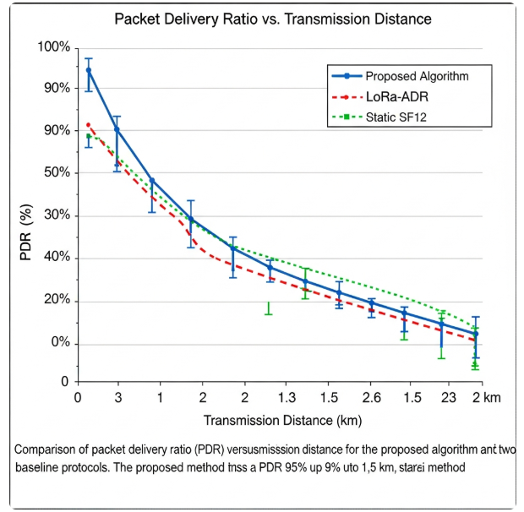
Figure 4.1: Comparison of packet delivery ratio (PDR)
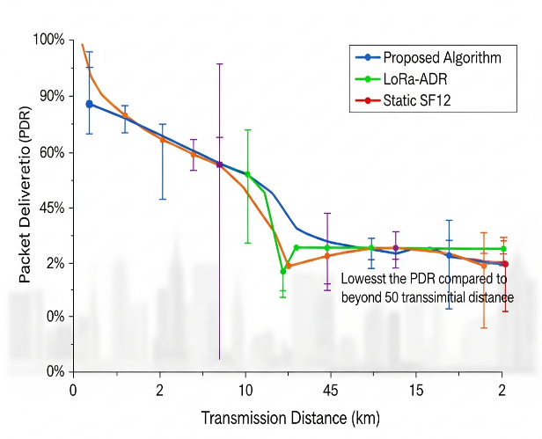
Figure 4.2: Comparison of packet delivery ratio (PDR)

*Note to Authors: Submit all figures as separate high-resolution files (.tiff, .eps, or .png, minimum 300 DPI).*

V. DISCUSSION
This section interprets your results, explaining their meaning, importance, and relevance. It connects your findings back to the literature and the research gap.
- Start with Key Findings: Begin by restating your most important result in the context of your research question.
- Interpret and Explain: What do your results mean? Why did you observe these trends? Compare your findings directly with those from the studies cited in your Literature Review. Do they support, contradict, or extend previous work?
- Address Implications: Discuss the theoretical and practical implications of your work. How does it change understanding or practice in the field?
- Acknowledge Limitations: Objectively state the limitations of your study (e.g., sample size, simulation assumptions, specific conditions tested). This strengthens credibility.
- Suggest Future Work: Based on your findings and limitations, propose concrete, logical directions for future research.
Replace this instruction block with your Discussion, weaving together your results and the existing literature.

VI. CONCLUSION
The conclusion should provide a concise, take-home message. It is not a summary.
- Restate the Objective: Briefly reiterate the problem you set out to solve.
- Synthesize the Answer: Concisely state how your work solved it. Highlight the one or two most significant outcomes that directly answer your research question.
- State the Broader Impact: What is the primary contribution or significance of your study to the field?
- Avoid: Repeating the abstract, introducing new data or ideas, lengthy summaries.
Replace this instruction block with a powerful, concise conclusion.

A) Declarations
The following statements are mandatory. Please complete each subsection. If a section is not applicable, state "Not applicable."

Funding: Detail any sources of financial support for the research. Include grant numbers.
Example: This work was supported by the National Science Foundation under Grant No. XXXXXXX. [OR] This research received no external funding.

Conflicts of Interest/Competing Interests: Declare any financial or non-financial interests that could be perceived as influencing the research.

Example: Author A is a consultant for Company Y. The other authors declare no conflicts of interest. [OR] The authors declare no conflicts of interest.

Ethical Approval: For studies involving humans, animals, or sensitive data.

Example: This study was approved by the Institutional Review Board of [Institution Name] (Protocol #XXXX). [OR] Not applicable.

Data Availability Statement: Explain how other researchers can access the data underlying your findings.

Example: The datasets generated and analyzed during this study are available in the [Repository Name] repository, [DOI or Persistent URL]. [OR] The data that support the findings are available from the corresponding author upon reasonable request.

Author Contributions: Use CRediT taxonomy roles to specify each author's contribution.

Example 1: Hardware/Experimental Paper
Author: P.K. (PhD student), M.J. (post-doc), R.L. (professor)
Conceptualization, R.L.
Methodology, P.K. and M.J.
Software, P.K.
Validation, M.J.
Formal Analysis, P.K.
Investigation, P.K. and M.J. (equally)
Resources, R.L.
Data Curation, P.K.
Writing – Original Draft Preparation, P.K.
Writing – Review & Editing, M.J. and R.L.
Visualization, P.K.
Supervision, R.L.
Project Administration, M.J.
Funding Acquisition, R.L

Example 2: Algorithm/Simulation Paper
Author: S.T., A.W., L.Z., H.C.
Conceptualization, S.T. and H.C.
Methodology, S.T.
Software, S.T. and A.W.
Validation, L.Z.
Formal Analysis, A.W.
Investigation, S.T.
Resources, H.C.
Data Curation, L.Z.
Writing – Original Draft Preparation, S.T. and A.W.
Writing – Review & Editing, L.Z. and H.C.
Visualization, A.W.
Supervision, H.C.
Project Administration, H.C.
Funding Acquisition, H.C

B) Acknowledgments
Thank individuals or organizations that provided non-financial assistance (technical help, materials, etc.).

REFERENCES
INSTRUCTIONS FOR AUTHORS: List all references cited in the text in APA 7th Edition format. Ensure every in-text citation has a corresponding reference here and vice versa. References should be recent, relevant, and from credible sources (journals, conferences, books). Do not use numbered/bulleted lists; use a hanging indent format.
[Authors: Replace this block with your reference list, formatted with a hanging indent. See examples below.]
Author, A. A., & Author, B. B. (Year). Title of article. Title of Journal, volume(issue), page range. https://doi.org/xxxxx
Author, C. C. (Year). Title of book (Edition). Publisher.
Author, D. D. (Year, Month). Title of paper. In Proceedings of the Conference Name (pp. xxx-xxx). Publisher.
Example:
- European Telecommunications Standards Institute. (2021). *ETSI TS 103 718: Smart city communications*. https://www.etsi.org
- Rodríguez, M., Kumar, P., & Yamada, T. (2022). *Communication protocols for low-power wide-area networks* (2nd ed.). Springer.
- Smith, J. A., & Chen, L. (2023). Advanced sensor networks for industrial IoT. *IEEE Sensors Journal, 23*(5), 4567-4578. https://doi.org/10.1109/JSEN.2023.1234567
- Wang, H., Li, Q., & Zhang, F. (2024, May 15-18). *Energy-efficient data transmission in 5G sensor arrays* [Conference presentation]. International Conference on Communications, Sydney, Australia

Submission Checklist (To be Removed Before Final Submission):
☐ Manuscript follows all template formatting (fonts, headings, spacing).
☐ All placeholder text and instructions have been removed.
☐ Author names, affiliations, and contact details are complete and accurate.
☐ Abstract is within 200-250 words; keywords are provided.
☐ All figures and tables are numbered, have captions, and are cited in the text.
☐ The "Declarations" section is fully completed.
☐ References are in correct APA 7th Edition format and cross-checked with citations.
☐ The manuscript has been proofread for language and grammar.

For Editorial Office Use:
Manuscript ID:
Received: [Date]
Revised: [Date]
Accepted: [Date]

Publication Information:
International Journal of Sensors and Communication Technologies (IJSCT)
Publisher: Le Celtique Publications
Website: www.celtiquepublications.fr
Submission: info@celtiquepublications.fr
Copyright: © 2026 by the authors. Published by Le Celtique Publications.
This is an open access article distributed under the terms of the Creative Commons Attribution License (CC BY 4.0).

